St Martins Parish Council
Clerk to the Parish Council
Edward Davies
9 Burnham Avenue
Belvidere Paddocks
Shrewsbury
Shropshire. SY2 5LL

Please ask for Edward Davies. Tel: Home 01743 366420 | 12th September 2014

E-mail: edward865davies@btinternet.com

To: All Members of Executive Committee
(Other circulation for information only)

Dear Sir/Madam

NOTICE IS HEREBY GIVEN that a MEETING of the ST MARTINS EXECUTIVE COMMITTEE will be held in the COMMUNITY CENTRE, ST MARTINS at 7.30 P.M. on THURSDAY 2nd OCTOBER 2014, or upon the rising of the Recreation Services Committee, whichever is the later, and Members are hereby summoned to attend for the purpose of transacting the following business.

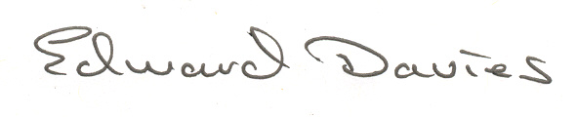
Signed …………………

Edward Davies PILCM

Clerk to the Parish Council

A G E N D A

106/10/14.E Apologies.

To receive apologies and approve reasons for absence.

107/10/14.E Declarations of interest and dispensations

To receive any declarations of interest relating to business to be conducted in this meeting and confirmation of any relevant dispensations.

108/10/14.E Minutes

To approve the minutes of the Executive Committee meeting held on the 3rd July 2014 (previously circulated).

109/10/14.E Recreation & Services Committee

To consider any proposals put forward by the Recreation Services Committee meeting held prior to this meeting.

110/10/14.E Shropshire Council Place Plan

To review the information currently contained within our Place Plan and notify Shropshire Council of any changes that we wish to make. (Copy to be circulated to Members).

Circulation: Councillors Neil Graham, Duncan Laing, Glen Pennington, Sue Schofield, John Stevens and Helen Williams.

